Kenneth Tran
CS4243
Project #1

Outline Design of an Online Store System

I. Goals:
1. Fast and secured platform for online store that sells digital products.
2. Cross-platform access control.
3. Ensuring the sensitive information accessible only by those who have the permission.
4. Completion of the transaction where a post cannot claim that it did not participate in it.

II. Architecture
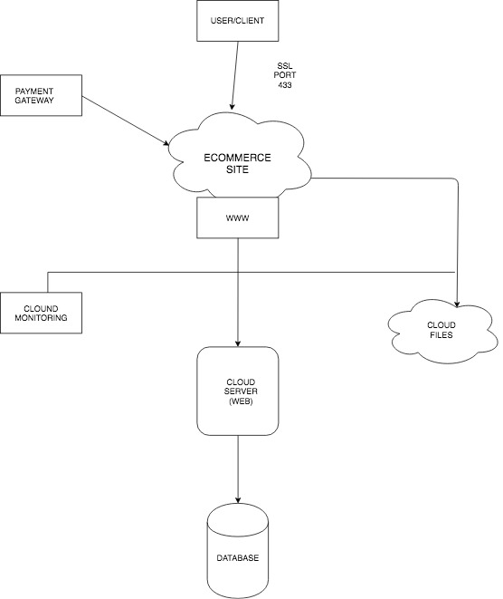

III. Security Design

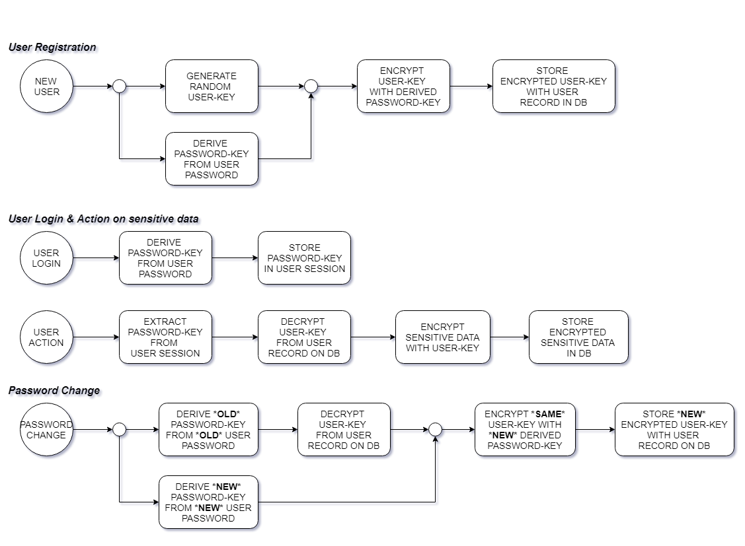

- User creates account with username and password – hashed password is stored in database.
- User logs in (persists across sessions) -- login token is stored in cookie.
- User inputs and submits text data – data is stored in database, but is sensitive and shouldn't be exposed even if database is compromised.
- Only the (logged in) user, and no one else, can read the submitted data.
- User should not need to enter any passphrase to encrypt/decrypt the data.

IV. Concurrency Control
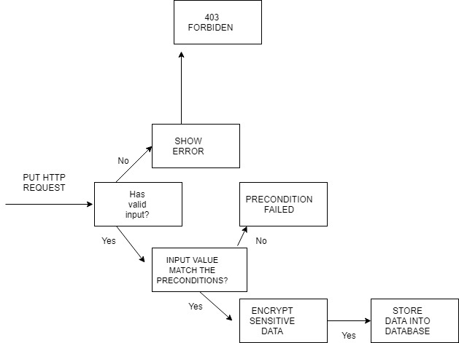

IV. Others

ER Diagram (sketchy)

